TSL Tutor – Working Principle

**© Anar Kazimov and Software Gates Team, 2016**

This document contains information about the working principle of the Turkish Sign Language tutor app and aims to create a smooth transition to the project.

# Main Functions

1. Detection of the preferable language. In this document we will mainly concentrate on the English version because Turkish one is easier to create.

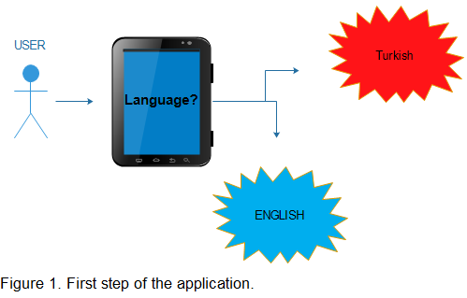

1. When user will use our app for a first time we will ask his name and we will show it in the Turkish Sign Language. Signs will be shown consequently using JavaScript.

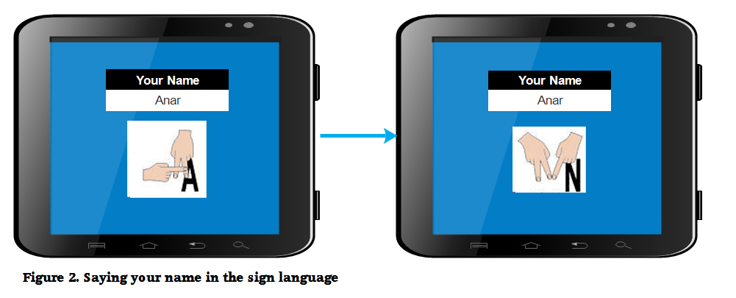

1. From now on user will see this page when will be entering the app. (By this we mean that user won’t be asked his name or language again, as for UI it had to be the same one in the previous images but for convenience we didn’t add purple background. TSL – Turkish Sign Language will be replaced by TID - Türk İşaret Dili in the Turkish branch of the app).

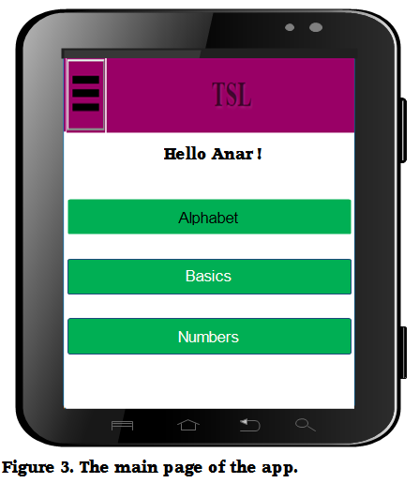

1. This is how alphabet page should approximately look like. The speaker is for non-deaf English speakers who want to learn how to pronounce this letter.

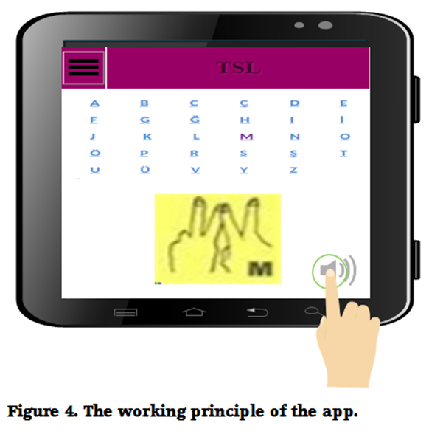

5. Basics page will containt a lot of interesting stuff:

6. At the moment we are not exactly sure of how number page will look like but we will base it on the material this guy teach: <https://www.youtube.com/watch?v=4vjsiCWM0yg>

Note: We are don’t owe the majority of the pictures used in this document and respect the rights of their authors.

